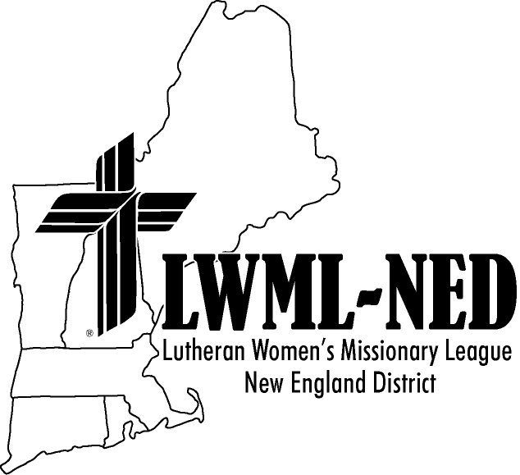
Lutheran Women’s Missionary League–New England District
Short-Term Missionary Project Scholarship Application
Please return completed application to:
Cindy Zattich, LWML-NED Vice President of Gospel Outreach,
5 Wilson Circle, Maynard, MA 01754
or via email to GospelOutreach@lwml-ned.org.

Name of Applicant:_________________________________________________________________

Home Address:____________________________________________________________________
street city state zip code

Home Phone Number (with area code):____________________________________

Home Email Address:__________________________________________________

Home Church:_____________________________________________________________________
Church Address:___________________________________________________________________
street city state zip code

Pastor:___________________________________________________________________________

Dates of Mission Project:_____________________________________________________________

Describe the purpose of the mission project:
________________________________________________________________________________

________________________________________________________________________________

Describe your motivation for participating in this mission project:
________________________________________________________________________________

________________________________________________________________________________

________________________________________________________________________________

Pastor’s Recommendation:
________________________________________________________________________________

________________________________________________________________________________

________________________________________________________________________________

_____________________________________
Pastor’s Signature
Upon my return from the mission project, I agree to share my experiences with the District organizations and/or churches and other groups when reasonably requested.

______________________________ __________
Applicant’s Signature Date
Lutheran Women’s Missionary League-New England District
Financial Data Form

Individual

Anticipated Total Cost of the Trip: __________________________

Resources

Subsidy from Sponsoring Organization: __________________________

Other Scholarships/Grants: __________________________

Anticipated Fundraising: __________________________

Total Resources __________________________

Groups

Anticipated Total Cost of Trip: __________________________

Number of Participants: __________________________

Resources

Subsidy from Sponsoring Organization: __________________________

Other Scholarships/Grants/Donations: __________________________

Anticipated Fundraising: __________________________

Total Resources __________________________

Signature of Applicant Date

