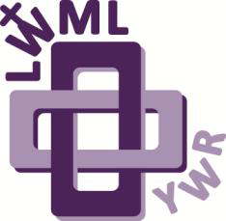Young Woman Representative to the

Lutheran Women’s Missionary League

New England District

29th Biennial Convention

Friday & Saturday, April 17-18, 2026

SpringHill Suites, Devens, MA

**WHO**: a mature young woman, preferably 22-35 years of age, who is a member of the LCMS and has not previously attended a district convention as a Zone Young Woman Representative; who has a deep love and devotion for her Lord Jesus Christ and is willing to participate in the full scope of the Convention.

**WHAT**: The **Lutheran Women’s Missionary League (LWML) New England District Convention**. The Convention includes missionary updates, business meetings, break-out sessions with interesting speakers or servant opportunities, Bible study, and lots of Christian sister fellowship!

**WHEN**: Friday, April 17th @ 1 pm to Saturday, April 18th @4 pm

**WHERE**: SpringHill Suites, 27 Andrews Pkwy, Devens, MA 01434

**HOW**: Compliments of the LWML-NED! We will pay for your hotel room on Friday night (shared with another YWR), plus dinner on Friday, and breakfast and lunch on Saturday.

**WHY**: Because love the LWML, we love you, and we’d like you to love the LWML!

LWML is also known as **Lutheran Women in Mission** and we think that phrase and our mission statement describe us perfectly: *The mission of the Lutheran Women in New England is to continue glorifying our God through acts of love, service, and encouragement toward each other and those whose lives we touch.*

**NEXT STEPS:** Fill out an application, scan, and submit it to our Young Women Committee at mrs.sage@veino.com.

Your reference may send their form to that email address separately if need be.

All paperwork is due back by March 1, 2026.

We look forward to meeting you and introducing you to the Lutheran Women’s Missionary League.