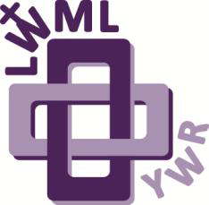Zone Young Woman Representative Application

LWML New England District 29th Biennial Convention

Friday & Saturday, April 17-18, 2026

SpringHill Suites, Devens, MA

Theme: Known By God Hebrews 139:13-14

Name _____________________________________________________Age _____________

Address_____________________________________________________________________

City, State, Zip______________________________________________________________

Occupation__________________________________________________________________

Home Congregation_________________________________________________________

Zone ________________________________________________________________________

Phone/email_________________________________________________________________

Please answer the following questions on a separate page:

1) The LWML motto is “Serve the Lord with gladness” (Psalm 100:2). How do you do this in your life?

2) What groups and activities are you involved in or have you been involved in at your church?

3) What do you know about the LWML? Have you been involved at any level?

4) Why do you desire to be a Young Woman Representative for your zone?

5) What do you feel your special interests, talents, and gifts are?

6) Your district is making a financial commitment to send you to the LWML convention. It will be an exciting and spiritually inspiring event. Do you intend to joyfully participate in the full scope of the convention?

Please have someone who knows you well, perhaps the person who encouraged you to apply, answer the following question, “Why do you feel this woman would make a good Young Woman Representative?”

Have them forward their response along with their name and relationship to you to one of the contacts below. Thank you!